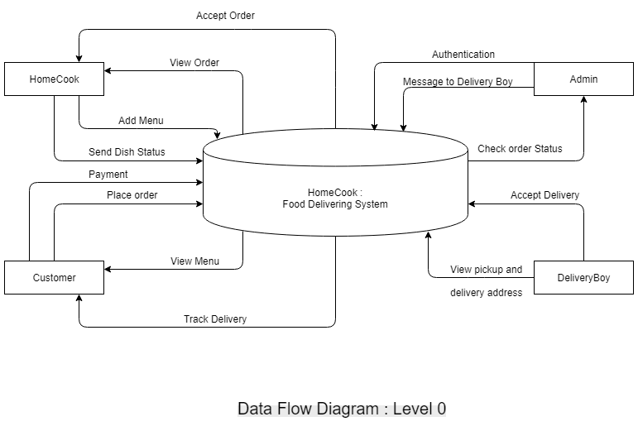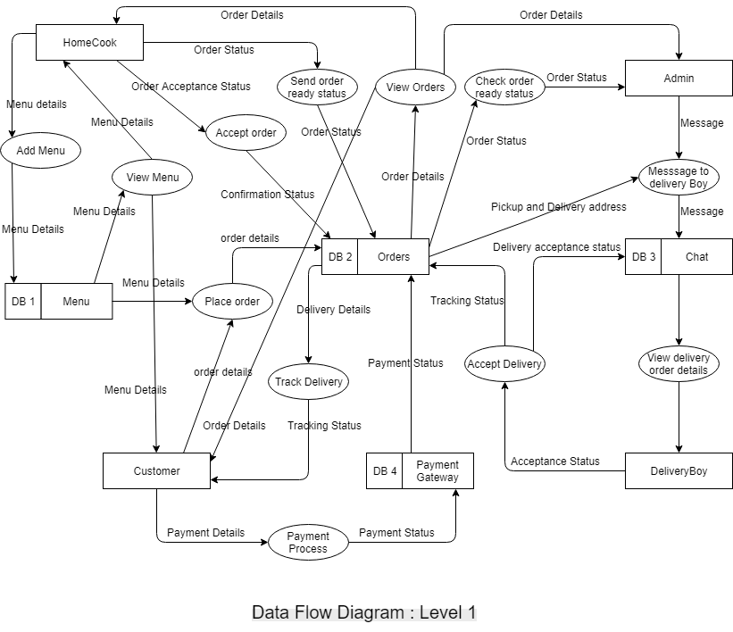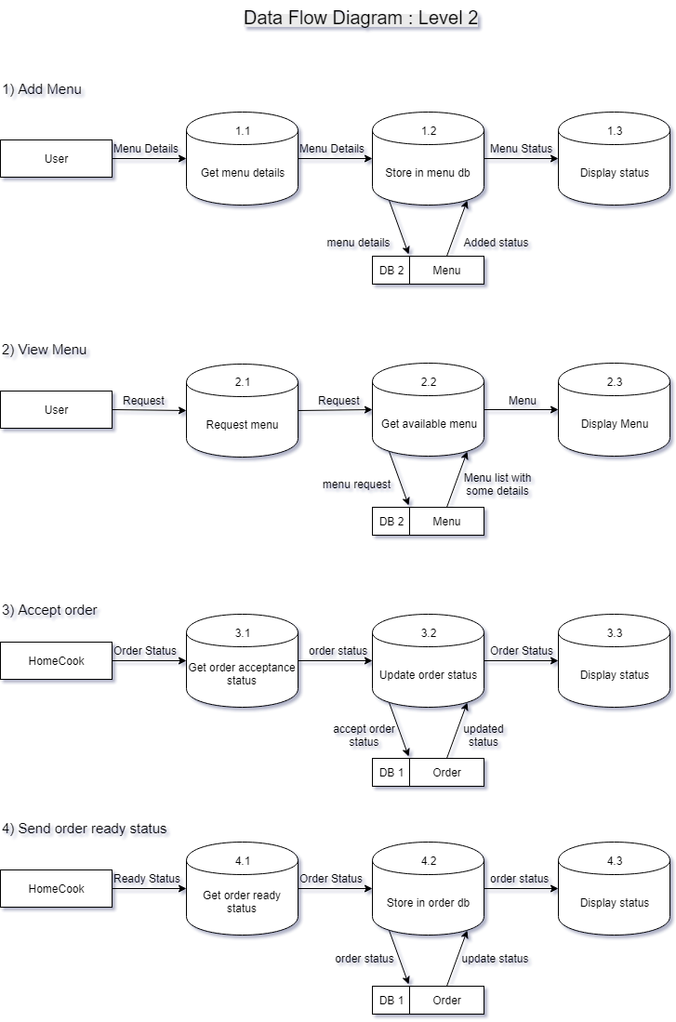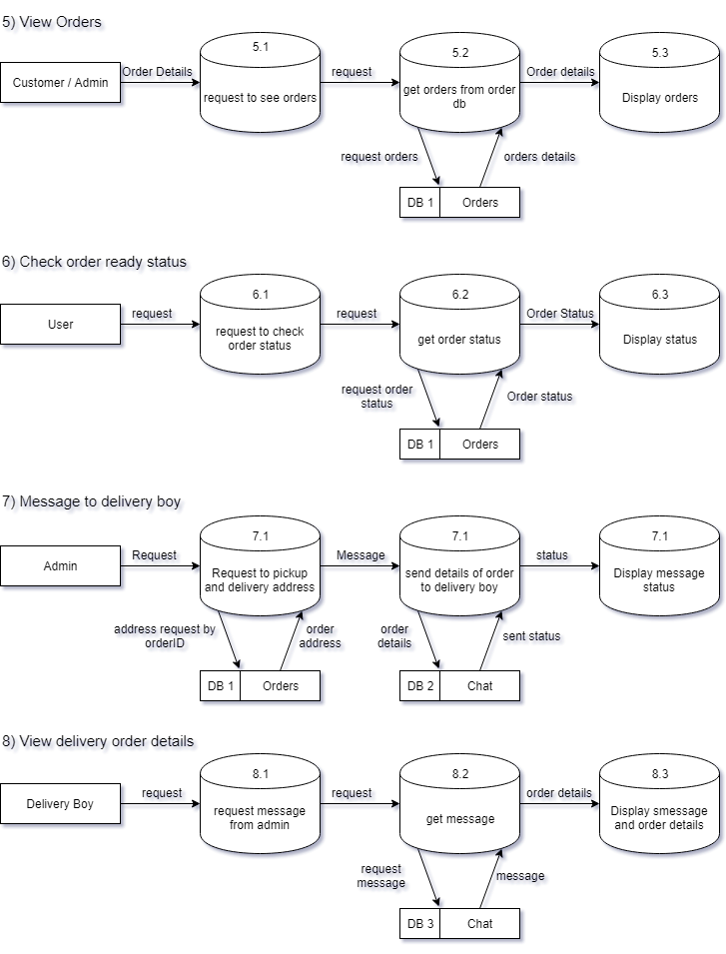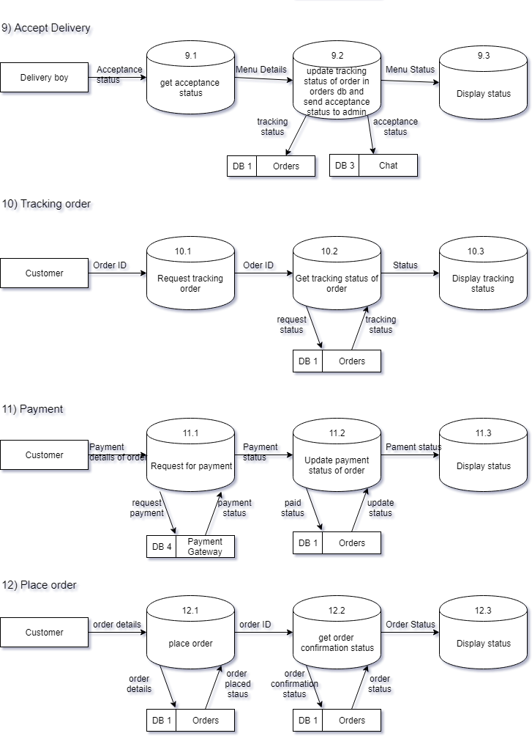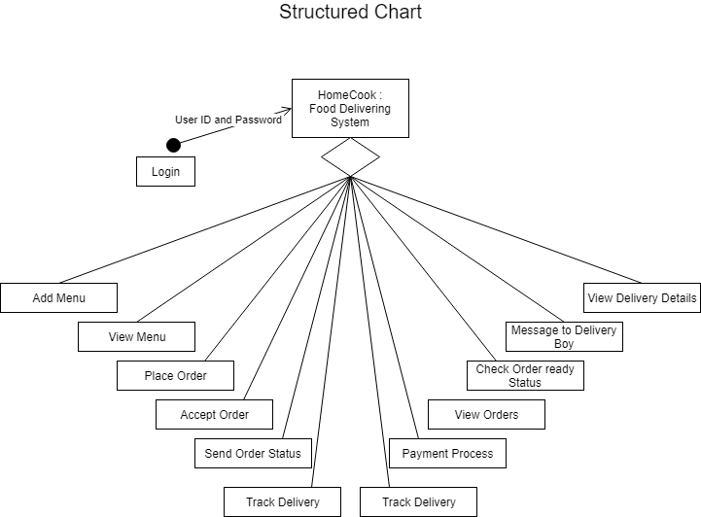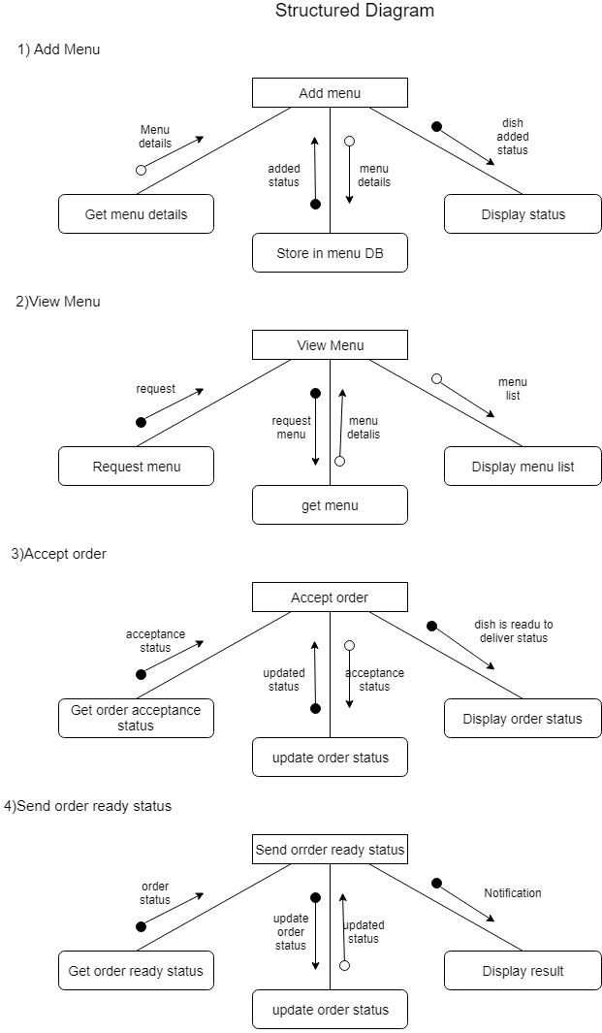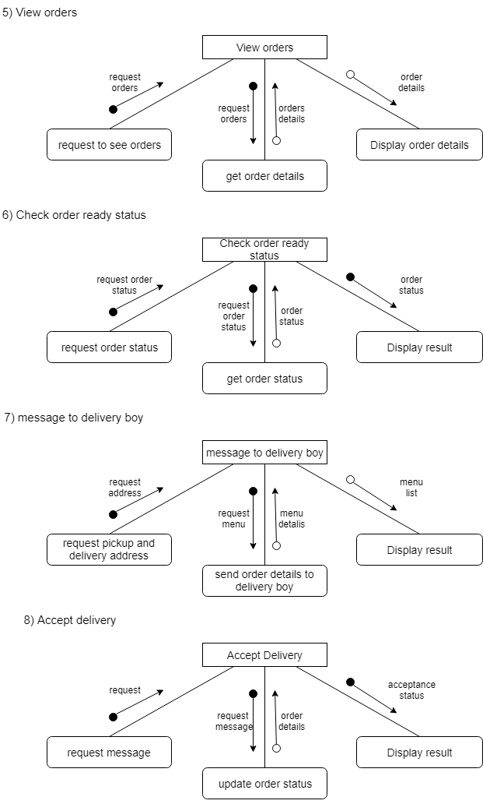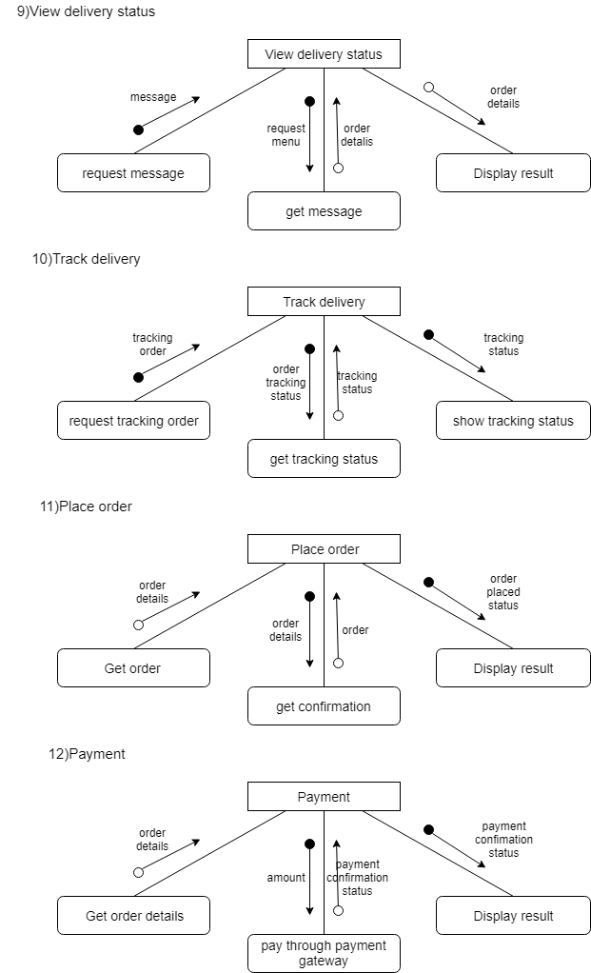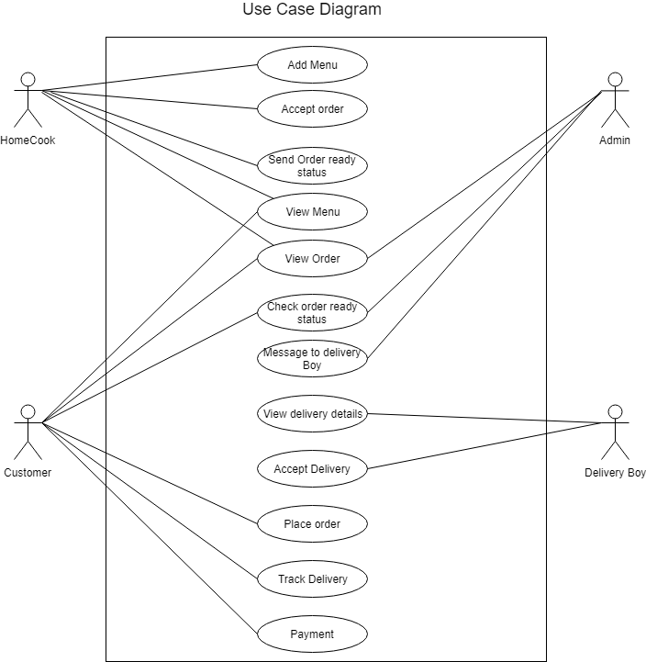

**Data Dictionary**

1. **Users**

|  |  |  |  |
| --- | --- | --- | --- |
| **Column Name** | **Data Type** | **Size** | **Type of User** |
| UserID | varchar | 20 | Homecook |
| Password | varchar | 20 | Customer |
| Name | Varchar | 35 | Admin |
| Gender | char | 6 | DeliveryBoy |
| Date of Birth | date | - |  |
| Address | varchar | 100 |  |
| EmailID | varchar | 30 |  |
| Phone No. | integer | 10 |  |

1. **Menu**

|  |  |  |
| --- | --- | --- |
| **Column Name** | **Data Type** | **Size** |
| DishID | varchar | 20 |
| HomecookID | varchar | 20 |
| Price | integer | 5 |
| Discount | integer | 2 |

1. **Orders**

|  |  |  |
| --- | --- | --- |
| **Column Name** | **Data Type** | **Size** |
| OrderID | varchar | 20 |
| CustomerID | varchar | 20 |
| DishID | varchar | 20 |
| Ready Status | boolean | - |
| Tracking Status | boolean | - |
| Date Time | Datetime | - |
| DeliveryBoy ID | varchar | 20 |
| Final Price | float | 10 |
| Payment | Boolean | - |

1. **Payment of orders**

|  |  |  |
| --- | --- | --- |
| **Column Name** | **Data Type** | **Size** |
| OrderID | varchar | 20 |
| TransactionID | varchar | 20 |
| Bank Name | varchar | 20 |
| Price | float | 5 |
| Payment Status | boolean | - |
| Date Time | datatime | - |

1. **Chat**

|  |  |  |
| --- | --- | --- |
| **Column Name** | **Data Type** | **Size** |
| DeliveryBoy ID | varchar | 20 |
| Chat | Varchar | 1000 |

